C CodeCraft'26
3-Hour C Programming Hackathon
Problem Scenario Options
Recommended for a 3-hour implementation and demonstration

Hackathon Overview
The following three scenarios are designed for a 3-hour C programming hackathon. Each scenario focuses on practical problem solving using core C programming concepts such as structures, arrays, strings, functions, searching, sorting, decision logic, and file handling as an optional advanced feature.
Scenario 1: Emergency Rescue Priority System

Scenario
During an emergency, a control room receives rescue requests from different locations. Each request contains information such as Request ID, Location, Number of People Affected, Emergency Level, Required Resources, Assigned Rescue Team, and Status. Students must develop a C program that automatically prioritizes emergency requests and manages rescue operations. The system should ensure that critical cases are handled before normal cases.

Example Record
Request ID : ER102
Location : Sathyamangalam
People : 15
Emergency : Critical
Resources : Ambulance
Status : Pending

Core Requirements
- Register emergency requests.
- Calculate or assign priority based on emergency conditions.
- Display requests according to priority.
- Assign an available rescue team.
- Update the status of a rescue request.
- Search for a specific request.
- Generate an emergency summary.

Advanced / Bonus Features
- Store and retrieve records using files.
- Use dynamic memory allocation.
- Manage multiple rescue teams and resource availability.
- Provide sorting using different criteria.
- Generate performance or response-time statistics.
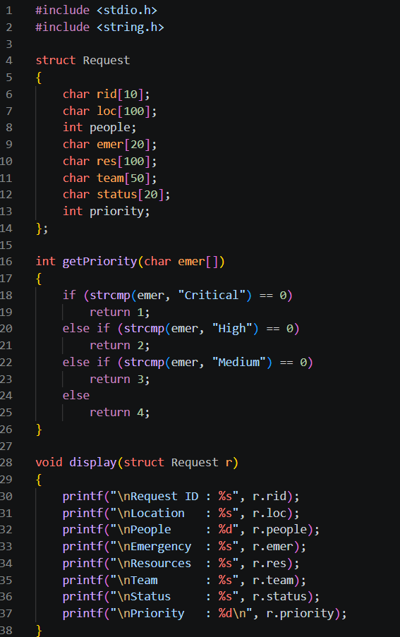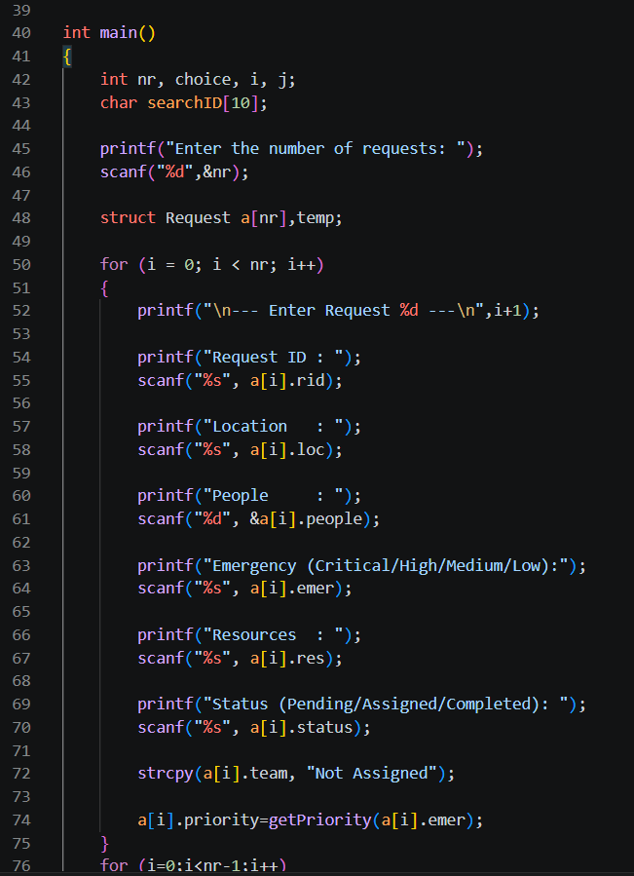
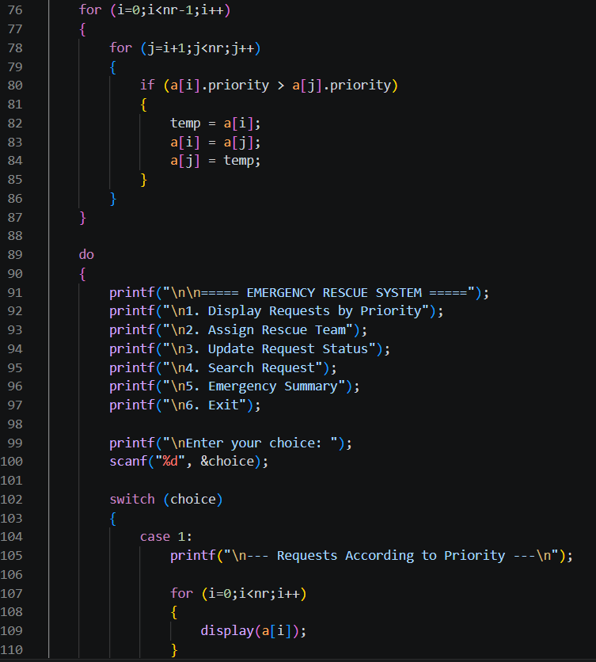
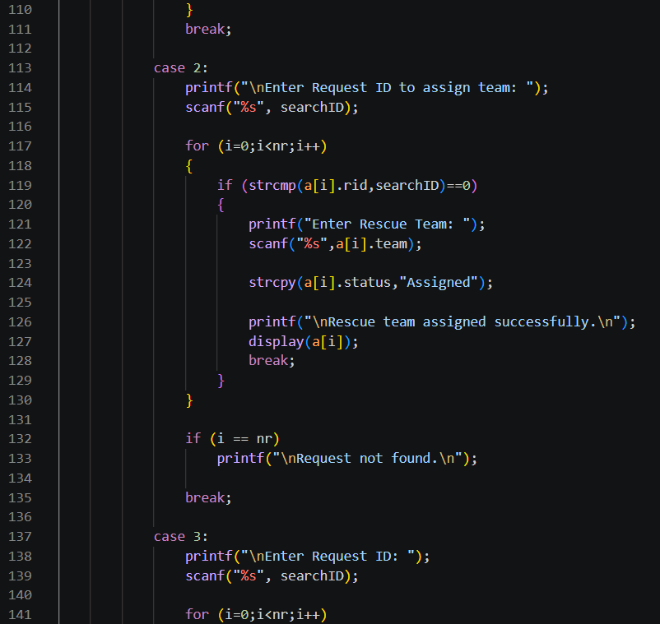
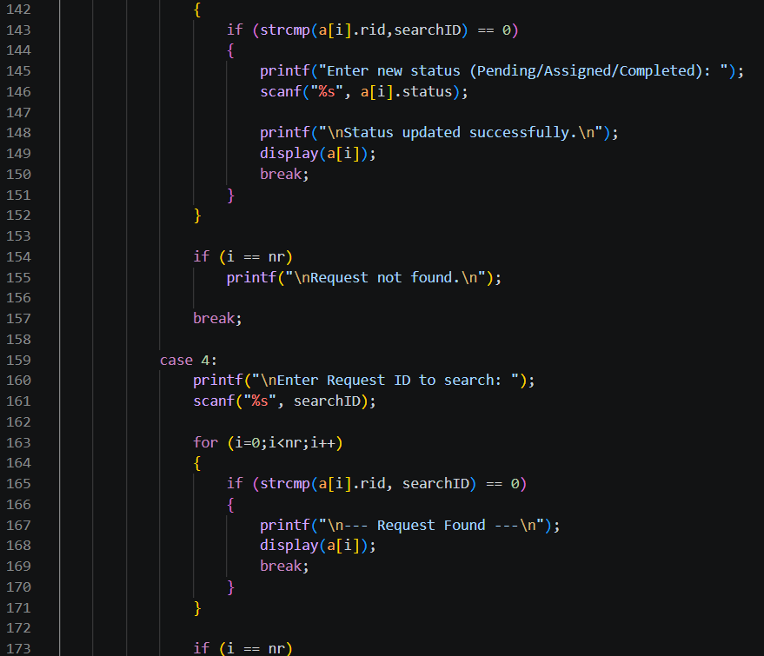
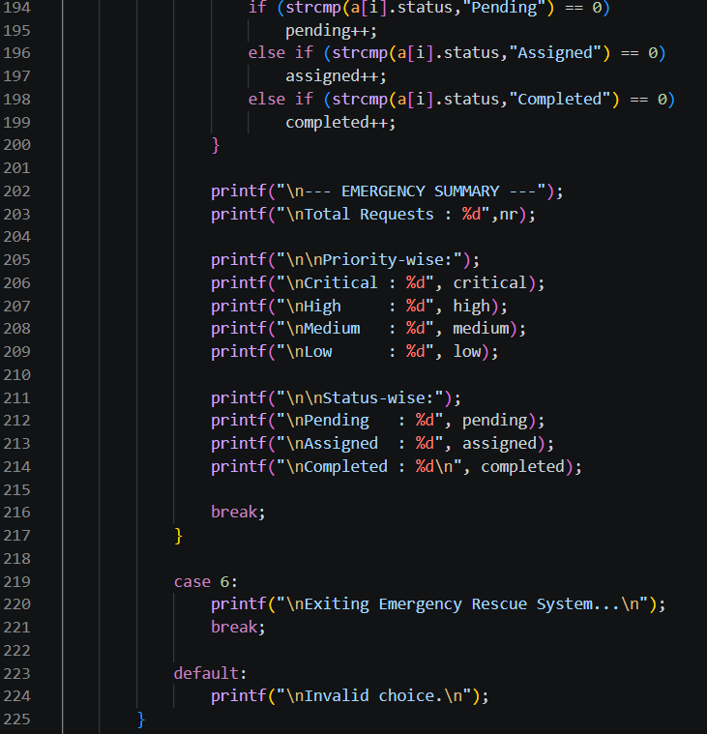
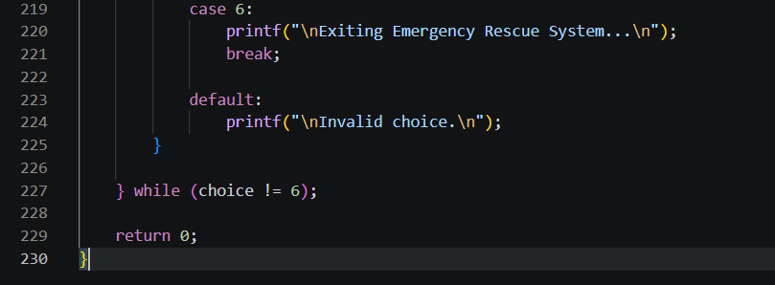

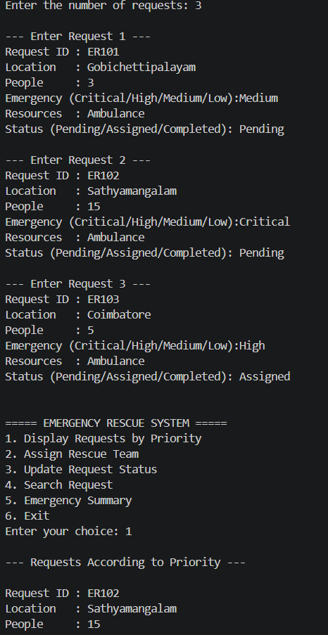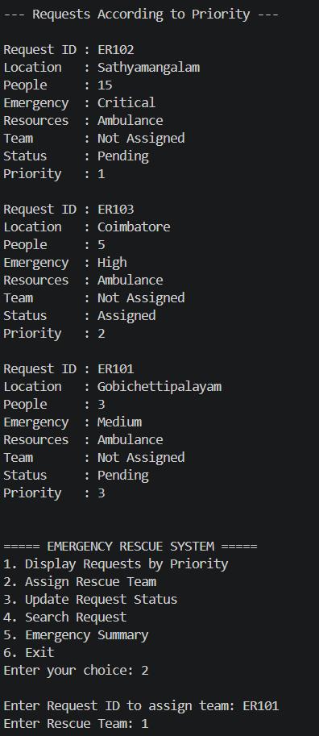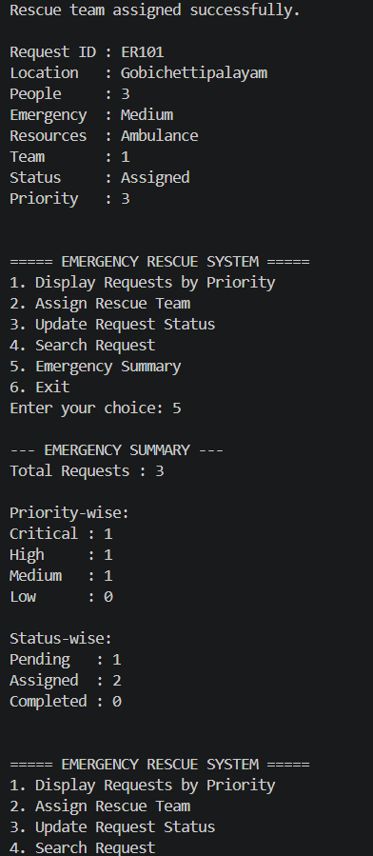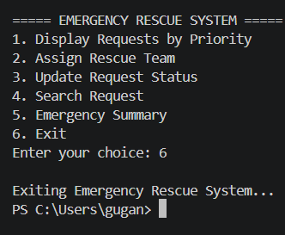

Scenario 2: Smart Campus Complaint System

Scenario
A college wants to manage student and faculty complaints related to laboratories, classrooms, hostels, transport, network services, electricity, and other campus facilities. Students must develop a C program that registers complaints, assigns priority, tracks progress, and produces useful summaries for the campus support team.

Example Record
Complaint ID : C105
Category : Laboratory
Problem : 8 computers not working
Priority : High
Location : CSBS Lab 3
Status : Pending

Core Requirements
- Register new complaints.
- Assign a priority based on complaint severity.
- Search for a complaint using its ID or other suitable information.
- Sort complaints based on priority or another selected criterion.
- Update complaint status such as Pending, In Progress, or Resolved.
- Display all pending complaints.
- Generate a complaint summary.

Advanced / Bonus Features
- Store complaints in a file and reload them when the program starts.
- Filter complaints by category, location, or status.
- Calculate department-wise complaint statistics.
- Implement multiple sorting options.
- Generate a simple resolution-performance report.

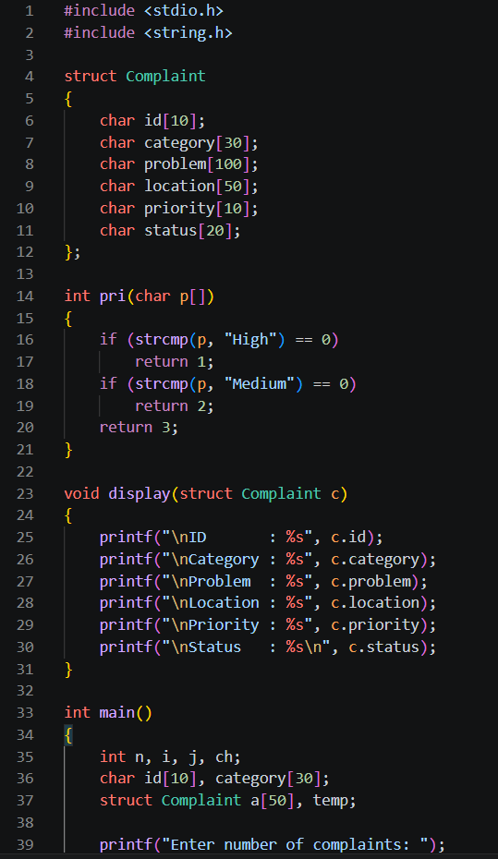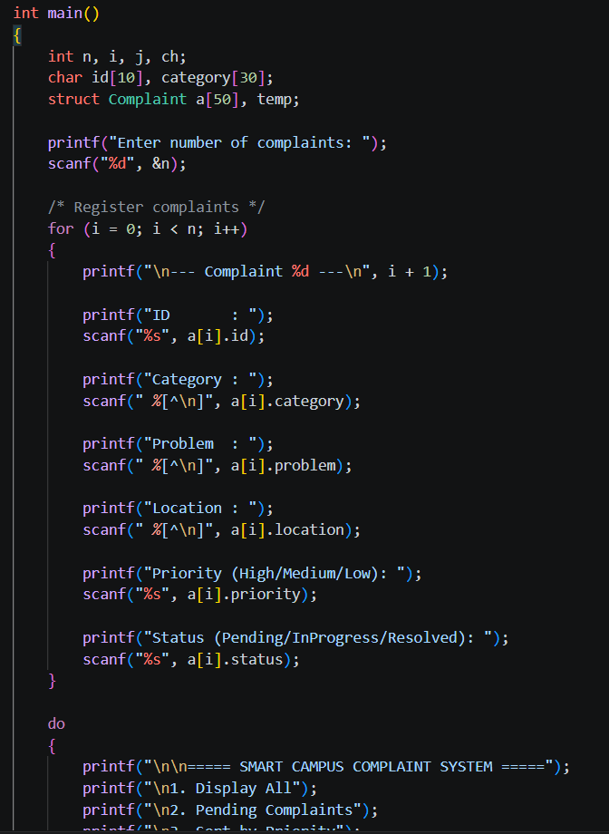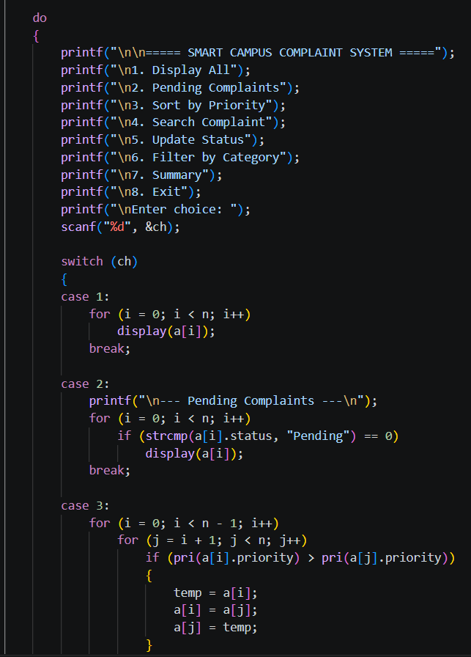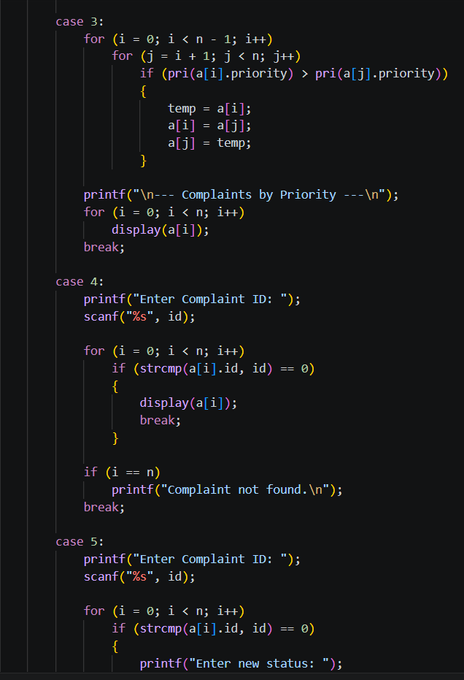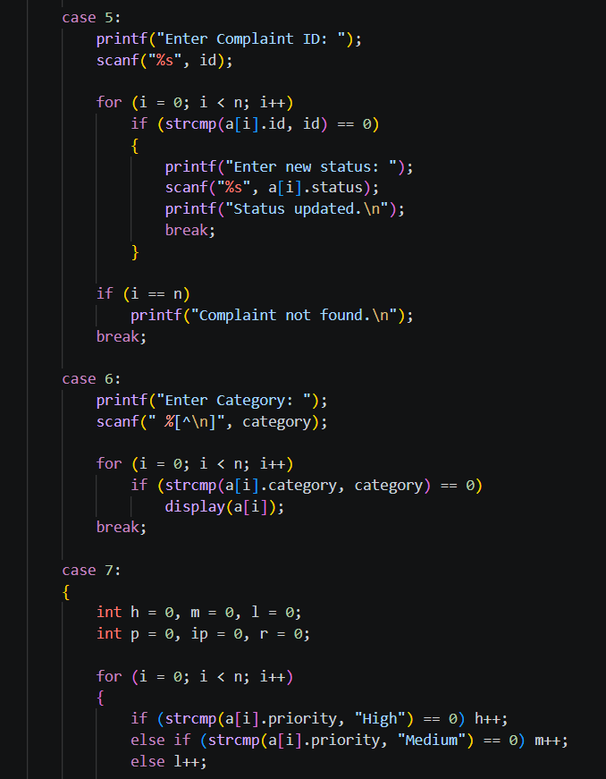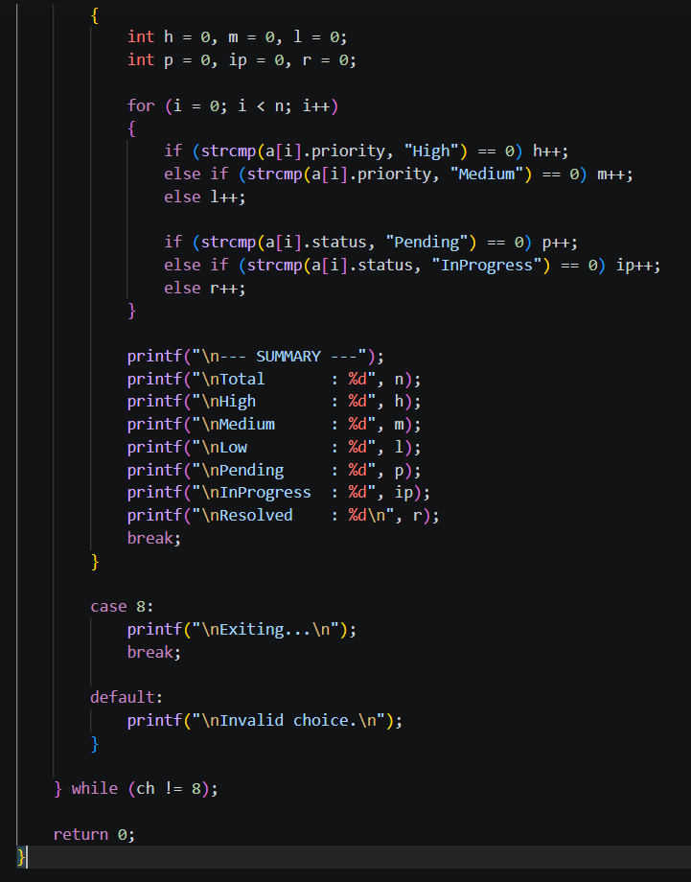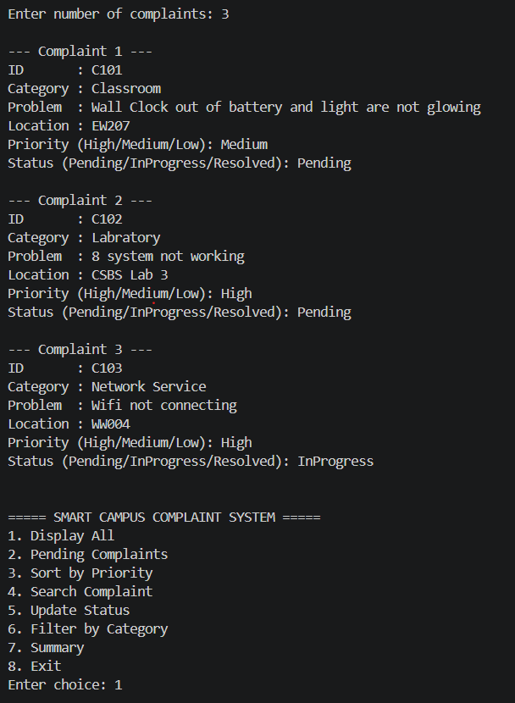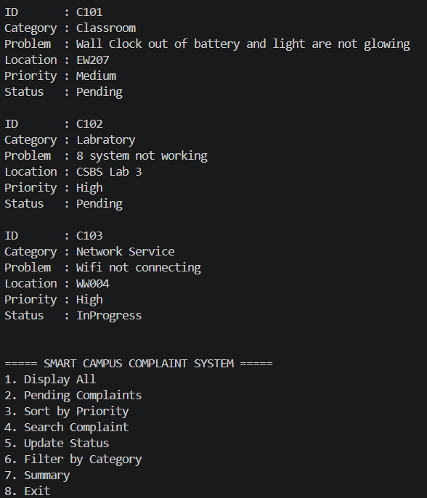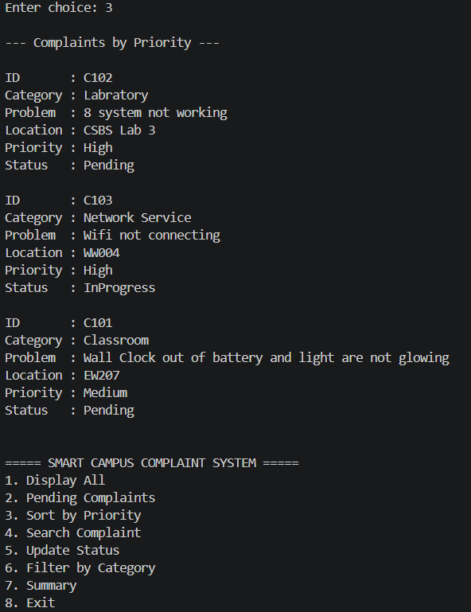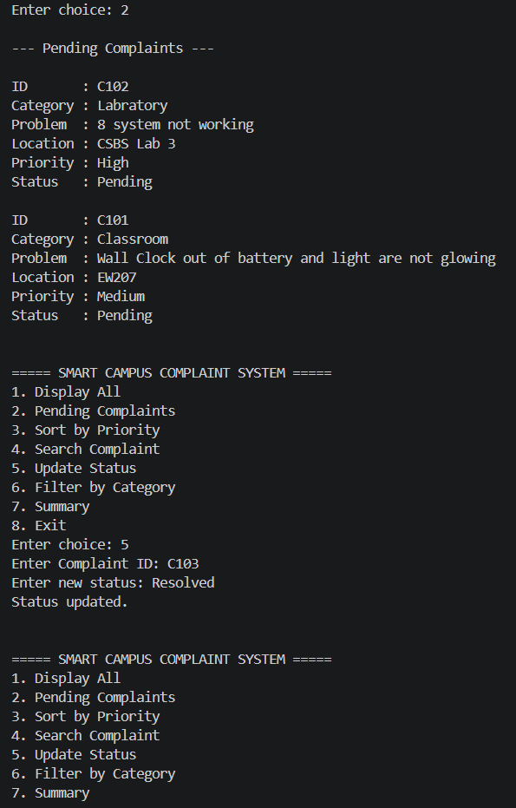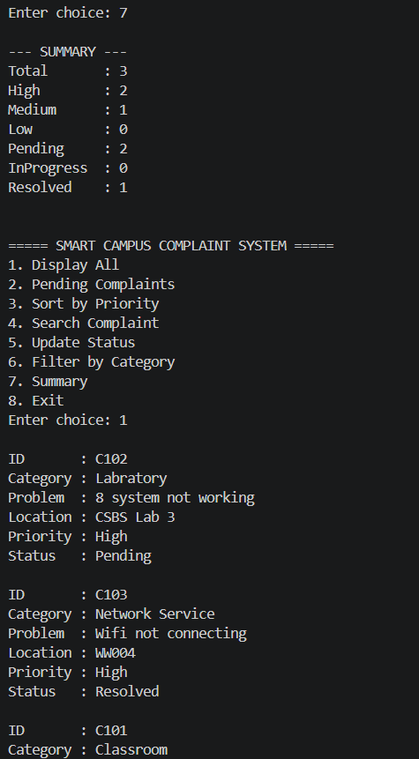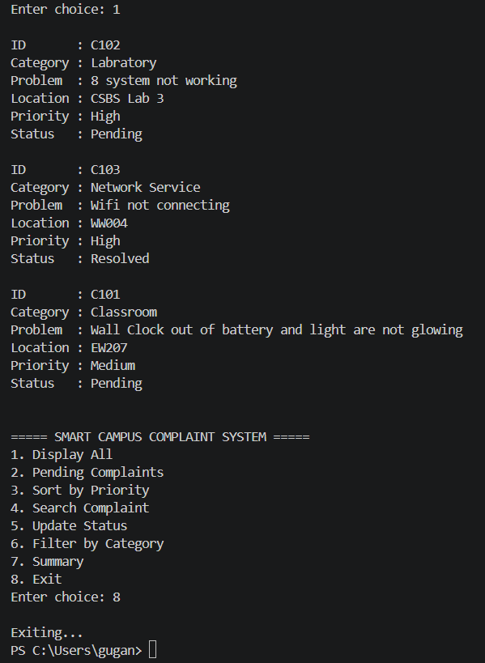

Scenario 3: Smart Hospital Emergency Queue System

Scenario
A hospital emergency department receives patients with different levels of urgency. Students must develop a C program to register patients, assign emergency priority, manage the waiting queue, assign available doctors or beds, update patient status, and generate an emergency department summary. Critical patients must be handled before lower-priority cases.

Example Record
Patient ID : P104
Name : Arun
Age : 45
Condition : Accident
Priority : 1 - Critical
Status : Waiting

Core Requirements
- Register a new patient.
- Assign an emergency priority.
- Display patients in priority order.
- Call the next highest-priority patient.
- Assign an available doctor or bed.
- Update patient status.
- Search for a patient.
- Generate a waiting-patient and treatment summary.

Advanced / Bonus Features
- Implement file-based patient records.
- Track doctor and bed availability.
- Calculate average waiting time.
- Provide different sorting or filtering options.
- Generate priority-wise patient statistics.

